

**Solution**:

First use file command on the file and you will see it’s a jpg file, so I renamed it to .jpg

Using binwalk command “**binwalk –e file_name**” extract the hidden zip inside the image

Then go to **gemini** and tell it to create a wordlist using all the words inside the image

After that use this command to find the password of the zip from the words that you extracted from the image

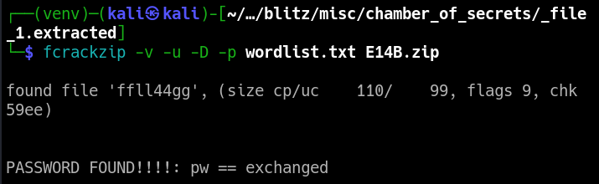

After that unzip the zip using unzip command using the found password

Then you will see a text file like this

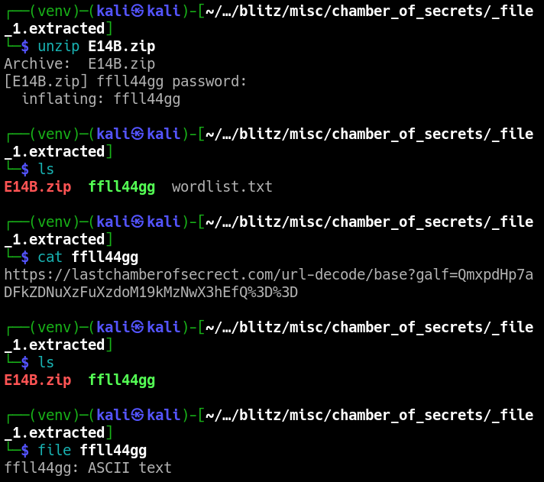

There you see a base64 cipher; decoding it you will have your flag